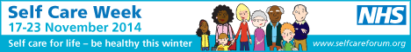
BALMORAL SURGERY
Don’t be left out in the cold, understand how to look after your winter ailments

Be healthy this winter.

http://www.selfcareforum.org/fact-sheets/ (Self Care Forum fact sheets)
http://www.treatyourselfbetter.co.uk/ (Treat Yourself Better website)
http://www.nhs.uk/Planners/Yourhealth/Pages/self-care-week-2014.aspx (NHS Choices)
http://antibioticguardian.com/ (Antibiotics Guardian)
http://www.rcgp.org.uk/clinical-and-research/target-antibiotics-toolkit/patient-information-leaflets.aspx (Antibiotics Awareness)

